Submitted by:   
Abdullah Al Noman   
Id: 242832  
Year 1st, Term 2ndLaw Discipline

Course Name: Principles of Sociology

Course Code: 0314 28 Soc 1253

Society is a Web of Social Relationship.

An Assignment on



# Table of Contents

1. Introduction 2

2. Social Relationship 3

3. The "Web" Metaphor 4

4. The Abstract Nature of Society 5

5. Conclusion 6

# 1. Introduction

For centuries, thinkers have sought to define what "*society*" truly is. Is it a physical place, a political entity, or simply a collection of people? The influential sociologist R.M. MacIver offered a profound and enduring answer, defining society not as a tangible object, but as *"The web of social relationships."* This definition fundamentally shifted the sociological perspective, moving away from viewing society as a static container for people and towards understanding it as a dynamic, abstract network of human connections. This essay will analyze MacIver's influential concept by deconstructing its two core components: the nature of *"social relationship"* as the building blocks of society, and the power of the "*web*" metaphor to illustrate society's intricate structure and function.



Figure 1: The web of relationships

# 2. Social Relationship

At the heart of MacIver's definition lies the concept of the "*social relationship*." A social relationship is far more than a fleeting interaction; it is a stable, recurring pattern of social conduct between individuals who are mutually aware of their connection. Unlike a brief, one-off social interaction, such as nodding at a stranger, a social relationship possesses a history and implies a future. It is built upon a foundation of continuous interaction, creating a predictable pattern of behavior.

These relationships are the essential threads from which the fabric of society is woven. They vary immensely in form and function, from the intimate and direct relationships within a family to the impersonal and indirect relationships between a citizen and their government. Whether cooperative, like a team working towards a common goal, or conflictual, like competing political parties, these patterned connections are the primary substance of social life. Without these ongoing relationships, we would merely have a crowd of individuals, not a society.

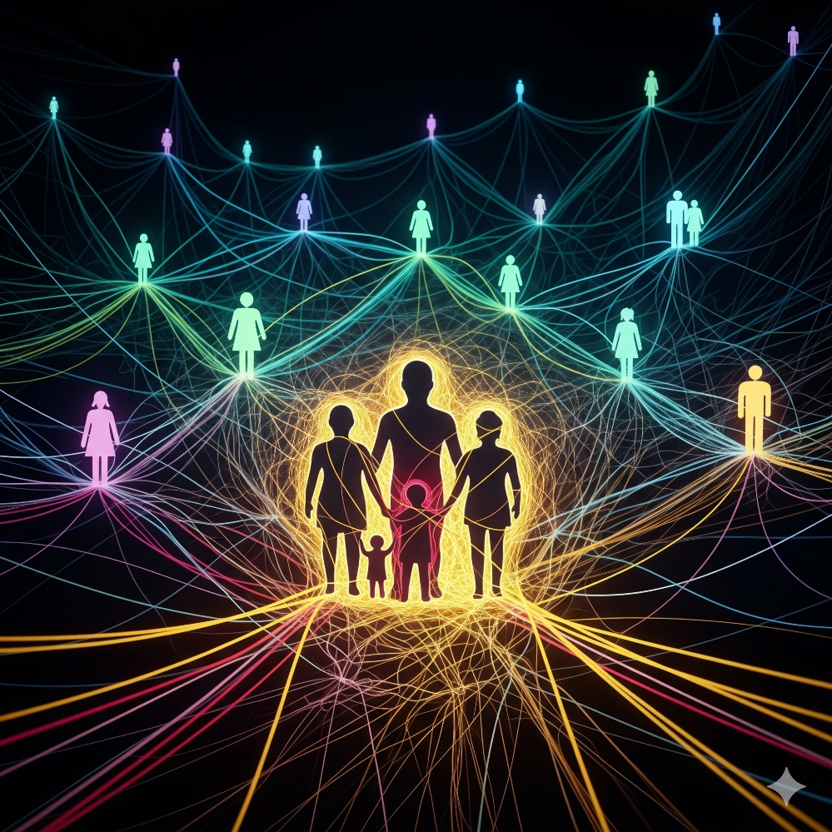

Figure 2: Social Relationship

# 3. The "Web" Metaphor

MacIver's choice of the word **"***web***"** is a deliberate and powerful metaphor that explains how individual relationships coalesce into a society. The image of a spider's web brilliantly illustrates three key sociological truths.

First, it powerfully conveys the concept of **interconnectedness**. In a web, no thread exists in isolation; a disturbance in one area sends vibrations throughout the entire structure, illustrating how individual actions and social phenomena are mutually influential. Just as a vibration in one part of a spider's web is felt across the entire structure, events in one area of society inevitably affect others. An economic downturn, for instance, is not an isolated event; its effects ripple through the web, impacting family structures, educational opportunities, and political discourse.

Figure 3: The Web of Social Institutions

Second, the metaphor suggests **structure and pattern**. A web is not a random tangle of threads but a complex, patterned creation. Similarly, society is not a chaotic mass of interactions but is characterized by recurring patterns of behavior, social institutions, and a discernible social structure.

Finally, the web signifies **complexity and intricacy**. Any individual exists at the intersection of numerous overlapping social relationships: family, friends, work, and community. The web metaphor captures how these countless threads crisscross to create a complex social identity for each person and a multifaceted structure for society as a whole.

# 4. The Abstract Nature of Society

A crucial implication of MacIver's definition is that society is fundamentally **abstract**. If society is the "web of social relationships," it is not something we can physically see or touch. We can see people, and we can see the results of their relationships (like laws, buildings, and art), but we cannot see the web itself. Society exists in the shared understandings, mutual expectations, and patterned behaviors that flow between individuals. It is a dynamic process, constantly being woven and re-woven through our daily interactions. This perspective distinguishes society from a "community" (which is often tied to a geographical location) and the "state" (a political apparatus). Society is the intangible network of connections that gives life to both.

# 5. Conclusion

R.M. MacIver's definition of society as "*the web of social relationships*" remains a cornerstone of modern sociology because of its profound simplicity and accuracy. By breaking society down into its essential components—stable relationships—and providing a powerful metaphor—the web—to explain their interconnectedness, MacIver offers a timeless framework for analysis. This perspective teaches us that society is not an external force acting upon us, but a complex and dynamic reality that we actively create and sustain through our every interaction. It is the sum of our connections, an intricate and ever-changing web that is both the product and the producer of human life.



Figure 4: Humanity Actively Weaving the Web of Social Relationships